

BAŞKENT UNIVERSITY
ELECTRIC & ELECTRONICS ENGINEERING

EEM 214 ~ ELECTRONICS–I
LABORATORY
REPORT

Experiment Name : Bipolar Junction Transistor
Experiment Number : 7

Student Name : Buğra BAYRAM
Student Number :20193272
Experiment Date/Day: 28 / 4 / 2006
Laboratory Number:

Honor Pledge:

I did this preliminary work or lab report by myself and I have neither cheat from anybody nor let anybody cheat from me at the any part of this work.

Student Signature:
……………………….

1-) We set the IB = 0 μA

IC = 0,01 mV / 1 K = 0,01 μA
VCE = 15,13 V

2-)

IB | IB | IC | VCE | β (Calculated)
5 μ | 5,05 μA | 2,58 mA | 12,565 V | 510
10 μ | 10,005 μA | 5,286 mA | 9,870 V | 528
15 μ | 15,09 μA | 7,901 mA | 7,247 V | 523
20 μ | 19,96 μA | 10,162 mA | 4,997 V | 509
25 μ | 24,94 μA | 12,151 mA | 3,003 V | 487
30 μ | 30,18 μA | 13,911 mA | 1,240 V | 460
35 μ | 35,11 μA | 14,646 mA | 0,493 V | 417
40 μ | 40,01 μA | 14,753 mA | 0,387 V | 368

IC = β x IB , β = IC / IB

β avarage = 3082 / 8 = 475

β measured = 510

3-)

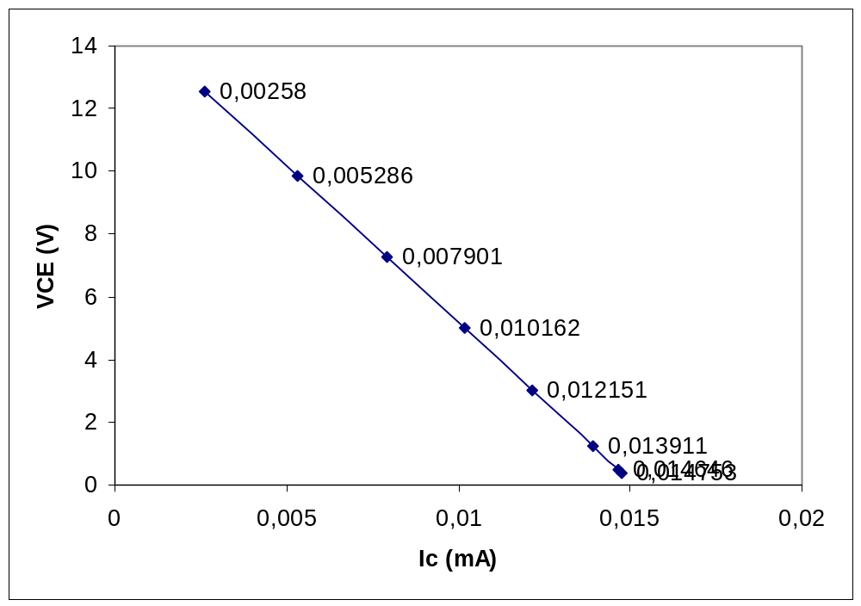
Ic versus VCE

4-)

IB | IC | VCE | β (Calculated)
50 μ | 14,86 mA | 0,278 V | 297
60 μ | 14,919 mA | 0,227 V | 248
70 μ | 14,945 mA | 0,202 V | 213
80 μ | 14,961 mA | 0,182 V | 187
90 μ | 14,972 mA | 0,175 V | 166
100 μ | 14,980 mA | 0,167 V | 149

5-)

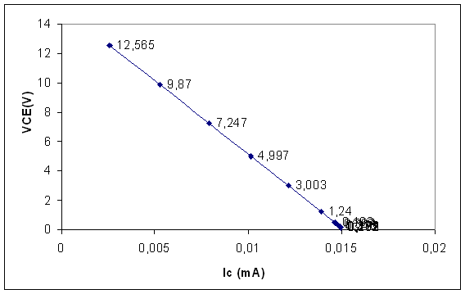

6-)
VCC | IC (mA) | VCE ( V )
15V | 10,230 | 4,963
14 V | 9,890 | 4,262
13 V | 9,750 | 3,484
12 V | 9,533 | 2,616
11 V | 9,313 | 1,805
10 V | 9,093 | 1,004
9 V | 8,717 | 0,379
8 V | 7,893 | 0,255
7 V | 6,894 | 0,199
6 V | 5,939 | 0,170
5 V | 4,918 | 0,149
4 V | 3,943 | 0,132
3 V | 2,927 | 0,115
2 V | 1,988 | 0,098
1 V | 0,992 | 0,074

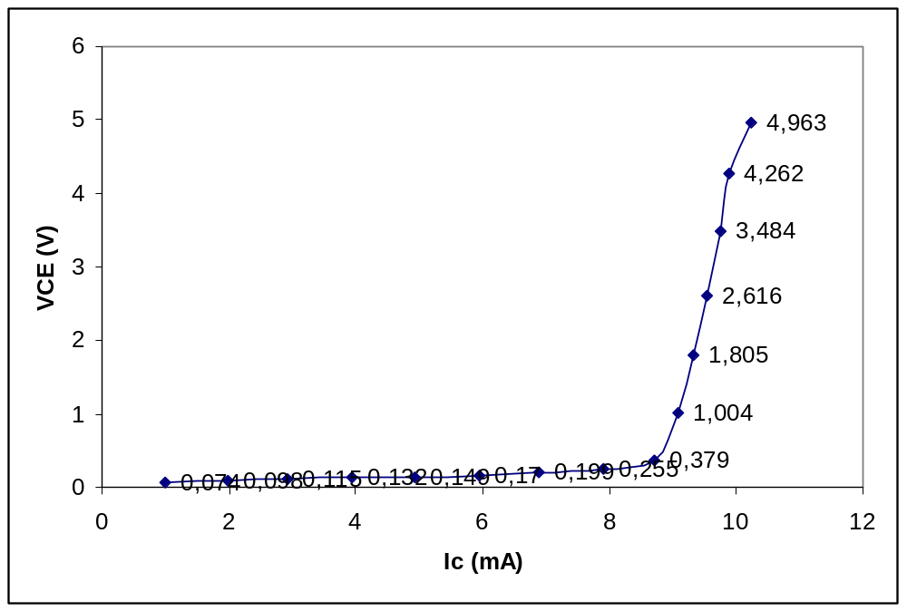

7-)

8-)

IB | IB (μA) | IC (mA) | VCE (V) | β (Calculated)
5 μ | 5,72 | 2,82 | 8,858 | 493
10 μ | 9,91 | 4,77 | 4,534 | 481
15 μ | 15,68 | 6,72 | 0,280 | 428
20 μ | 20,20 | 6,77 | 0,188 | 335
25 μ | 24,58 | 6,78 | 0,165 | 275
30 μ | 30,64 | 6,78 | 0,149 | 221
35 μ | 35,34 | 6,79 | 0,140 | 192
40 μ | 40,18 | 6,79 | 0,134 | 168
50 μ | 50,59 | 6,79 | 0,124 | 134
60 μ | 59,74 | 6,80 | 0,117 | 113
70 μ | 70,26 | 6,80 | 0,111 | 96
80 μ | 80,43 | 6,80 | 0,106 | 84

